20MCA136 – NETWORKING & SYSTEM ADMINISTRATION LAB Dept. of Computer Applications

NETWORKING & SYSTEM ADMINISTRATION LAB

Name: Vishnu Vijayakumar
Roll No: 53
Batch: B
Date: 12-05-2022

Experiment No.: 19

Aim
Write a shell script to find the sum of digits of a number entered.

Program

echo -e "enter the number" read n
sum=0 a=$n
while(($n>0)) do
x=`expr $n % 10` sum=`expr $sum + $x` n=`expr $n / 10`
done
echo "the sum of $a is $sum"

Output screenshot

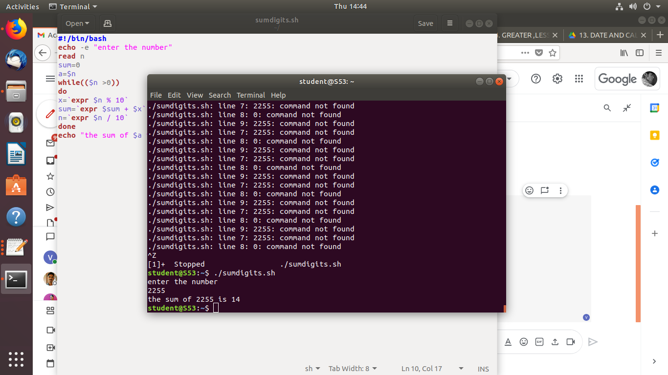

Amal Jyothi College of Engineering, Kanjirappally

